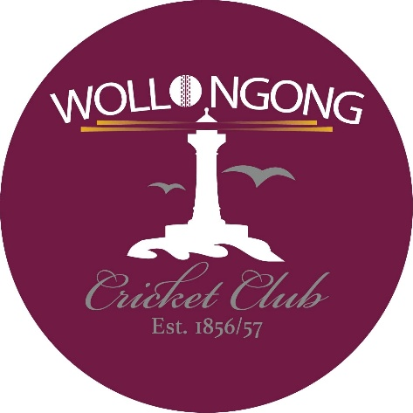

Wollongong District Cricket Club Social Media Use Policy
Endorsed on: ________________________________
Signed By: ________________________________
Signature: ________________________________
Review Date: ________________________________

PURPOSE
Social Media is an important business tool and allows Affiliated Associations, Clubs and Indoor Centres to communicate and engage with a variety of audiences in a manner that is timely and cost- effective. The purpose of the Cricket Participant Social Media Use Policy (Policy) is to encourage positive and effective use of Social Media by Affiliated Associations, Clubs and Indoor Centres and Cricket Participants while ensuring appropriate standards, which protect the interests and reputation of Australian Cricket.
The Policy also outlines the circumstances in which the use of Social Media will be monitored, and the actions which will be taken in respect of breaches of this policy.

SCOPE
This Policy applies to all Wollongong District Cricket Club Participants including players, umpires, coaches, volunteers and committee members.
This Policy applies to Social Media in the following situations:
- Cricket-related Social Media where the Cricket Participant is posting as a representative of Wollongong District Cricket Club on branded Social Media page or site; and
- Personal use of Social Media by a Cricket Participant whenever they are identifiable as an Wollongong District Cricket Club member and when they are posting about Wollongong District Cricket Club including its Cricket Participants, teams, sponsors or other stakeholders.

POLICY DETAIL

Cricket-Related Social Media
Only Wollongong District Cricket Club representatives who are authorised as part of their role are permitted to post material or content on the page or profiles representing the entity. Such posts must be consistent with the Spirit of Cricket and Values and must comply with 1.3 Expectations of Appropriate Social Media Use below.

Personal Use of Social Media
Cricket Participants are encouraged to share their passion for cricket by posting photos and information to Social Media in a positive manner. Such posts must be consistent with the Spirit of Cricket and values of Wollongong District Cricket Club.

Expectations of Appropriate Social Media Use
    - Be respectful.
All Cricket Participants must treat all others with dignity, courtesy and respect when using Social Media. Posts should be consistent with the State or Territory Cricket Association’s Code of Conduct, Member Protection Policy, Australian Cricket’s Framework for Safeguarding Children and Young People, and other relevant policies.
    - Maintain Privacy and Confidentiality
You may have access to sensitive, private and confidential information and intellectual property that is not in the public domain including information about Cricket Participants, sponsors or Australian Cricket entities. If you are unsure whether information is confidential, you must confirm with that person or organisation before it is posted.
    - No disparaging comments
Social Media posts made by Cricket Participants should in no way disparage other Cricket Participant, clubs or associations.
Do not post or link to content that contains illegal or indecent content, including defamatory, vilifying or misleading and deceptive content.

    - Use of Image and Copyright
If publishing photos or videos on Social Media that may contain children, prior consent is required as per the Australian Cricket Framework for Safeguarding Children and Young People.
You must obtain express permission from an individual to use a direct, clearly identifiable image of that person.
You should also refrain from posting any information or photos of a sensitive nature. This could include accidents, incidents or controversial behaviour.
Only publish material they have the right to publish. Do not upload or post content belonging to a third party unless you have obtained have their explicit prior written consent.

BREACH OF POLICY
  - If a Cricket Participant believes that they may have breached this Policy, they should immediately remove the relevant Social Media post or comment and discuss the matter with a Club or Association representative immediately.
  - If a Cricket Participant notices a post or comment posted by someone else that may be a breach of this policy, they are asked to take a screenshot and report the comment to a Club or Association representative.
  - A breach of this Policy may be considered serious and require the Club or Association to refer the incident to the State or Territory Cricket Association in accordance with the Member Protection or Complaints and Disputes Policy.

RELATED DOCUMENTS, LEGISLATION AND STANDARDS
This document should be read and implemented in conjunction with:
- Code of Conduct relevant to the State or Territory Cricket Association
- Member Protection Policy relevant to the State or Territory Cricket Association
- Australian Cricket’s Framework for Safeguarding Children and Young People
- Community Cricket Social Media Use Guidelines
- Relevant Federal, State or Territory Legislation, including The Online Safety Act 2021

DEFINITIONS:

Affiliated Associations, Clubs and Indoor Centres means any cricket association or club or indoor centre that has agreed to be bound by this Policy.

Cricket Participant means:
- Directors, committee members and officers of Wollongong District Cricket Club
- Employees, consultants or contractors of Wollongong District Cricket Club
- Volunteers of Wollongong District Cricket Club
- Players that are registered with or entitled to participate in the activities of Wollongong District Cricket Club
- Coaches (including assistant coaches), who:
  - hold a Cricket Coaches Australia Accreditation unless the coach falls within the definition of Australian Cricket Personnel;
  - are appointed and/or engaged by Wollongong District Cricket Club
  - have an agreement (whether or not in writing) with an Affiliated Association, Club or Indoor Centre to coach in a facility owned or managed by the State and Territory Cricket Association; or
  - have an agreement (whether or not in writing) with an Affiliated Association, Club or Indoor Centre to coach in a facility owned or managed by the Affiliated Association or Club
- Umpires, selectors and other officials, who:
  - hold a Cricket Umpires Australia Accreditation unless the umpire falls within the definition of Australian Cricket Personnel; or
  - umpire or officiate cricket matches for Affiliated Associations, Clubs or Indoor Centres
- Cricket Blast Coordinators
- Team support staff;
- Parents/guardians holding a specific role within Wollongong District Cricket Club (including regular scorers); and
- Any other person who has agreed to be bound by this Policy

Social Media means any online media (including websites and applications whether on a desktop computer, tablet or mobile device) that allows Cricket Participants to create, share, broadcast or exchange information, ideas, and pictures/videos in virtual communities and networks.
Commonly used Social Media platforms in Australia include Facebook, Instagram, TikTok, WhatsApp, YouTube and many others.

Spirit of Cricket means the Preamble to the Laws as published which promotes respect, fairness, and positive conduct by all participants, upholding the game’s values beyond its Laws

